Daniel Meyer

CSE 420-01

Lab 4

Drawing Polygons

**Lab 4 Report**

**Part 1: (Success)**

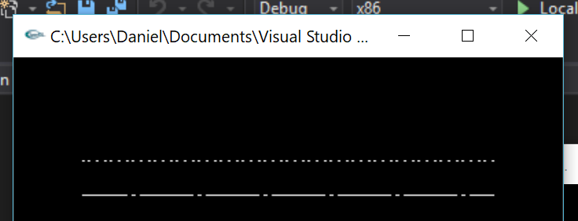

glLineStipple(3, 0xD7FF); /* long dash/dot/long dash */

drawOneLine(50.0, 150.0, 350.0, 150.0);

glLineStipple(2, 0x2525); /* long dash/dot/long dash */

drawOneLine(50.0, 175.0, 350.0, 175.0);

**Part 2: (Success)**

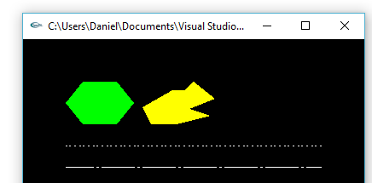

glColor3f(0.0, 1.0, 0.0);

glBegin(GL_POLYGON);

glVertex2f(70.0, 200.0);

glVertex2f(50.0, 225.0);

glVertex2f(70.0, 250.0);

glVertex2f(110.0, 250.0);

glVertex2f(130.0, 225.0);

glVertex2f(110.0, 200.0);

glEnd();

glColor3f(1.0, 1.0, 0.0);

glBegin(GL_POLYGON);

glVertex2f(150.0, 200.0);

glVertex2f(140.0, 220.0);

glVertex2f(175.0, 240.0);

glVertex2f(200.0, 240.0);

glVertex2f(225.0, 230.0);

glVertex2f(200.0, 250.0);

glVertex2f(190.0, 220.0);

glVertex2f(220.0, 210.0);

glVertex2f(180.0, 200.0);

glEnd();

**Part 3: (Success)**

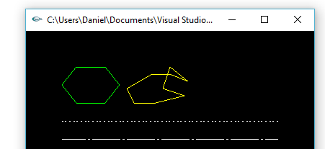

glPolygonMode(GL_FRONT_AND_BACK, GL_LINE);

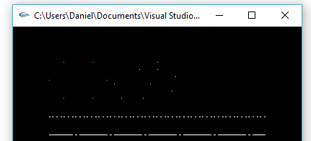

glPolygonMode(GL_FRONT_AND_BACK, GL_POINT);

**Part 4: (Success)**

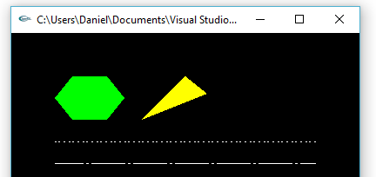

glEnable(GL_CULL_FACE);

glCullFace(GL_BACK);

glFrontFace(GL_CCW);

glColor3f(0.0, 1.0, 0.0);

glBegin(GL_POLYGON);

glVertex2f(110.0, 200.0);

glVertex2f(130.0, 225.0);

glVertex2f(110.0, 250.0);

glVertex2f(70.0, 250.0);

glVertex2f(50.0, 225.0);

glVertex2f(70.0, 200.0);

glEnd();

glColor3f(1.0, 1.0, 0.0);

glBegin(GL_POLYGON);

glVertex2f(180.0, 200.0);

glVertex2f(220.0, 210.0);

glVertex2f(190.0, 220.0);

glVertex2f(200.0, 250.0);

glVertex2f(225.0, 230.0);

glVertex2f(200.0, 240.0);

glVertex2f(175.0, 240.0);

glVertex2f(140.0, 220.0);

glVertex2f(150.0, 200.0);

glEnd();

**Summary:**

For this assignment I used the lines.cpp file provided to create the patters asked for in Part 1. Next using GL_POLYGON I created 6 and 9 sided polygons with green and yellow respectively. Then redrew the polygons using different polygon modes (GL_LINE and GP_POINT). Finally drew the polygons with the vertices in counterclockwise direction and the other in clockwise direction with culling. The code compiles without error as well as according to the desired output as such I believe I earned a full 20 points.